Unveiling The Virtual Classroom: An In-Depth Analysis of the Online Education System

Dr. Santhi Krishnan, Professor,

School of Computer Science Engineering, Vellore Institute of Technology, Vellore, Tamilnadu. India

# Define Problem

The traditional education landscape is undergoing a significant transformation due to the rapid advancement of technology, resulting in the widespread adoption of online education systems. However, this transition has brought forth a multitude of challenges and opportunities that need to be comprehensively understood and addressed. The problem at hand is to gain a deep understanding of the evolving online education system, including its various components, pedagogical approaches, effectiveness, accessibility, and its impact on education stakeholders. This analysis seeks to uncover the complexities, nuances, and implications of the online education system to inform better decision-making, improvements, and innovations in this rapidly changing educational landscape.

In essence, the problem revolves around the need to analyze and evaluate the online education system comprehensively, considering its multifaceted nature and its impact on education in the digital age. This analysis aims to provide valuable insights, data-driven assessments, and informed recommendations to educators, policymakers, institutions, and stakeholders navigating the challenges and opportunities presented by the virtual classroom.

# Business Problem

Educational institutions, EdTech companies, policymakers, and stakeholders are facing the challenge of effectively harnessing the potential of online education systems amidst a rapidly evolving technological and educational landscape. This challenge encompasses issues related to the quality of online learning experiences, equitable access to digital education, the optimization of educational technology, the adaptation of pedagogical methods, and the alignment of online education with broader educational goals. To make well-informed decisions, investments, and strategic choices in the realm of online education, there is an urgent need for a comprehensive analysis that delves deep into the opportunities, challenges, and best practices associated with virtual learning. The business problem at hand is to navigate the complexities of the digital transformation of education and leverage the advantages of online education while addressing its associated challenges.

The primary business problem addressed by this project is to investigate the inclusivity of the online education system. The business problem can be explores as following:

* Efficacy of productive engagement and learning outcomes: The chief objective of any online education system is to ensure the productive engagement of learners and optimal achievement of learning outcomes. The success of online education platforms largely depends on how well they can replicate the interactive and participative nature of traditional classrooms. If students are disengaged or fail to grasp the material adequately, it can lead to reduced satisfaction, lower completion rates, and potentially affect the reputation and profitability of the online education provider.
* Reliable and qualitative deliverable : The increasing landscape of the online education system needs to assure the quality as well as establishment of credibility. The educational institutions and online platforms need to prove the legitimacy of their courses and certifications to attract students and gain the trust of employers. Without proper mechanisms in place to ensure academic integrity, there is a risk of devaluing the credentials and diminishing the reputation of the institution.
* Compete market and establish distinctiveness: The online education industry has become increasingly competitive, with numerous providers vying for a share of the market. In this scenario, businesses face the challenge of standing out and differentiating their offerings to attract and retain learners. Understanding the unique strengths and weaknesses of their platform and courses can help companies refine their marketing strategies and target specific niches effectively.
* Accessibility and Comprehensiveness: Online education has the potential to break geographical barriers and make learning accessible to a broader audience. However, accessibility and inclusivity remain a significant challenge. Businesses need to address issues related to the digital divide, accommodating diverse learning needs, and making their platforms user-friendly for differently-abled individuals. Failure to address these concerns can lead to missed opportunities to tap into underserved markets and may even raise ethical considerations.
* Agility and Integration: Advancements in technology continually shape the landscape of online education. Businesses in this domain must keep abreast of emerging technologies and explore how they can enhance the learning experience. Integrating new tools and features effectively requires a keen understanding of learner preferences and technological trends.
* Financial sustainability and revenues generation: For businesses offering online education, the sustainability of their models depends on effective monetization strategies. They must find a balance between offering accessible and affordable courses while generating sufficient revenue to cover operational costs and invest in continuous improvement.
* Compliance with regulatory bodies: Online education is subject to various regulations and legal requirements that can vary across jurisdictions. Ensuring compliance with these regulations is crucial to avoid legal challenges and maintain the reputation of the business.
* Security and privacy: Online education platforms collect vast amounts of student data, ranging from personal information to learning behavior. Ensuring robust data privacy and security measures is essential to protect students' sensitive information and maintain trust with users.

# Business Requirements

# The business requirements for an online education system encompass a wide range of functional and non-functional specifications that are essential for its successful operation and alignment with business goals. These requirements help define what the system should achieve and how it should operate within the context of the educational institution or organization. Here is a list of key business requirements for an online education system:

1. User Authentication and Authorization:

Ensure secure user authentication with role-based access control to differentiate between administrators, instructors, and students.

1. Course Management:

Create and manage courses, including course descriptions, schedules, and enrollment capacities.

Support course cataloging and categorization for easy discovery.

1. Content Management:

Enable the creation, uploading, and management of course materials, including text, multimedia, assignments, and assessments.

1. User Profiles:

Allow users to create and maintain profiles with personal information, academic records, and preferences.

1. Communication and Collaboration:

Provide tools for communication and collaboration among users, including discussion forums, chat, email, and video conferencing.

1. Learning Management:

Implement a learning management system (LMS) to track and manage student progress, grades, and performance. Support automatic grading and feedback mechanisms.

1. Assessment and Evaluation:

Offer tools for creating and administering quizzes, exams, assignments, and assessments.

Enable peer assessment and self-assessment options.

1. Enrollment and Registration:

Facilitate student enrollment, registration, and payment processing for courses. Managem waitlists and course capacities.

1. Analytics and Reporting:

Provide analytics and reporting capabilities for instructors and administrators to track student progress, engagement, and course effectiveness.

1. Content Delivery:

Ensure smooth content delivery through a reliable content delivery network (CDN). Support video streaming and multimedia content.

1. Mobile Accessibility:

Ensure the platform is accessible via mobile devices and supports responsive design for various screen sizes.

1. Accessibility Compliance:

Comply with accessibility standards (e.g., WCAG) to ensure that the platform is usable by individuals with disabilities.

1. Security and Data Privacy:

Implement robust security measures to protect user data and prevent unauthorized access.

Comply with data privacy regulations (e.g., GDPR, FERPA) and ensure user data is handled securely.

1. Scalability and Performance:

Design the system to be scalable to accommodate a growing number of users and courses.- Ensure high performance and minimal downtime.

1. Integration:

Integrate with external systems, such as student information systems (SIS), content repositories, and authentication services.

1. Content Authoring Tools:

Provide tools for instructors to create and edit course content, quizzes, and assessments.

1. Support and Helpdesk:

Offer user support, including helpdesk services, FAQs, and documentation.

1. Payment and Billing:

- Handle payment processing for course fees and subscriptions securely.

1. Marketing and Promotion:

Support marketing efforts, including course promotion, email campaigns, and user engagement initiatives.

1. Compliance and Reporting:

- Ensure compliance with educational regulations and reporting requirements.

# Literature Survey

Conducting a comprehensive literature survey of the online education system with references would typically involve an extensive review of academic papers, research studies, reports, and articles related to online education.

1. Allen, I. E., & Seaman, J. (2017). Digital Learning Compass: Distance Education Enrollment Report 2017. Babson Survey Group.

This report provides data and insights into the growth and trends of online education in the United States.

1. Anderson, T., & Dron, J. (2011). Three generations of distance education pedagogy. International Review of Research in Open and Distributed Learning, 12(3), 80-97.

This paper discusses the evolution of distance education pedagogy and its relevance to online education.

1. Means, B., Toyama, Y., Murphy, R., Bakia, M., & Jones, K. (2009). Evaluation of Evidence-Based Practices in Online Learning: A Meta-Analysis and Review of Online Learning Studies. U.S. Department of Education.

A comprehensive meta-analysis examining the effectiveness of online learning compared to traditional face-to-face instruction.

1. Bates, A. W., & Sangrà, A. (2011). Managing technology in higher education: Strategies for transforming teaching and learning. Jossey-Bass.

Discusses strategies for integrating technology effectively in higher education, including online learning.

1. Garrison, D. R., Anderson, T., & Archer, W. (2000). Critical inquiry in a text-based environment: Computer conferencing in higher education. The Internet and Higher Education, 2(2-3), 87-105.

Explores the concept of critical inquiry in online learning environments.

1. Moore, M. G. (1993). Theory of transactional distance. In D. Keegan (Ed.), Theoretical principles of distance education (pp. 22-38). Routledge

Discusses the theory of transactional distance, which is relevant to understanding online education.

1. Picciano, A. G. (2017). Theories and frameworks for online education: Seeking an integrated model. Online Learning, 21(3), 166-190.

Examines various theories and frameworks relevant to online education and proposes an integrated model.

1. Siemens, G., & Tittenberger, P. (2009). Handbook of Emerging Technologies for Learning. University of Manitoba.

Provides insights into emerging technologies that have the potential to transform online education.

1. Hodges, C., Moore, S., Lockee, B., Trust, T., & Bond, A. (2020). The difference between emergency remote teaching and online learning. Educause Review, 27.

Discusses the distinction between emergency remote teaching (as seen during the COVID-19 pandemic) and well-designed online learning.

1. Salmon, G. (2013). E-tivities: The key to active online learning (2nd ed.). Routledge.

Explores the concept of e-tivities and how they can be used to engage learners in online environments.

# Social and Business Impact

The nuanced analysis of the online education system will have significant social and business implications. Understanding the effectiveness of online education can positively impact learners by improving engagement, learning outcomes, and accessibility to education. It can also provide valuable insights to educational institutions and online platforms, enabling them to enhance their offerings, create more engaging learning experiences, and make informed decisions about resource allocation and course development. Additionally, by addressing challenges and capitalizing on opportunities, the project can contribute to the growth and sustainability of the online education industry, benefiting both providers and learners on a global scale.

# Data Collection

The Dataset in the given problem consists of 23 columns and 1033 rows. The column Column Description for Online education system review:

* Gender: Gender of the student
* Home Location: Rural or Urban.
* Level of Education : UG, PG or school
* Age : age of the student
* Number of subjects :
* Device Type Used : device used to attend the online classes
* Economic status : economic status of the family
* Internet facility in your locality
* Are you involved on any sports
* Family Size
* Do elderly people monitor you?
* Study Time(hours)
* Sleep time (hours)
* Time spent on social media(hours)
* Interested in gaming?
* Have a separate room for studying?
* Engaged in group studies?
* Average marks scored before pandemic in traditional classroom
* Your interaction in online mode
* Clearing doubts with faculties online?
* Interested in?
* Performance in online
* Your level of satisfaction in online education

# Connection with IBM Cognos

IBM Cognos is a powerful business intelligence and performance management tool that enables organizations to access, analyze, and visualize data from various sources. It offers advanced reporting, dashboarding, and data modeling capabilities, facilitating data-driven decision-making. Cognos seamlessly connects to diverse data repositories and provides insights through user- friendly interfaces, contributing to enhanced business performance and strategic planning.

Steps: Login to IBM Cognos —-> Launch IBM Cognos —-> Go to the prepare data section —-> click on upload option —->upload the csv file.

# Data Preparation

Preparing the data for visualization involves cleaning the data to remove irrelevant or missing data, transforming the data into a format that can be easily visualized, exploring the data to identify patterns and trends, filtering the data to focus on specific subsets of data, preparing the data for visualization software, and ensuring the data is accurate and complete. This process helps to make the data easily understandable and ready for creating visualizations to gain insights into the performance and efficiency. Data preprocessing can be performed in many ways using many different steps depending on the data. Renaming the data columns and cleaning of rough data have been performed on collected dataset using IBM Cognos.

# Data Visualization and Data Dashboard

The total 13 unique visualizations have been created from the given dataset. The types of visualizations include bar charts, line charts, heat maps, scatter plots, pie charts etc. These visualizations can be used to compare performance, track changes over time, show distribution, and relationships between variables, resource allocation, etc.

The responsiveness and design of a dashboard for online education review data is crucial to ensure that the information is easily understandable and actionable. Key considerations for designing a responsive and effective dashboard include user-centered design, clear and concise information, interactivity, data-driven approach, accessibility, customization, and security. Here, the goal is to create a dashboard that is user-friendly, interactive, and data-driven. Four tabs has been included in the dashboard from the pinned visualization in IBM Cognos. Refer Figure 1- Figure 4 for dashboard.

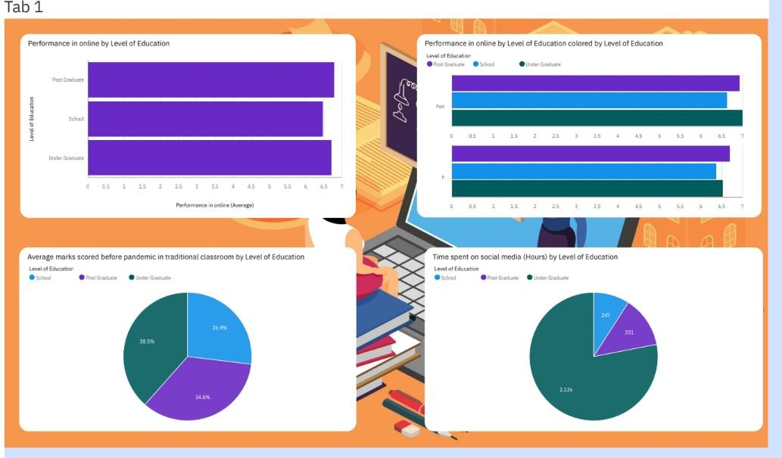

*Figure 1 : Visualization 1*

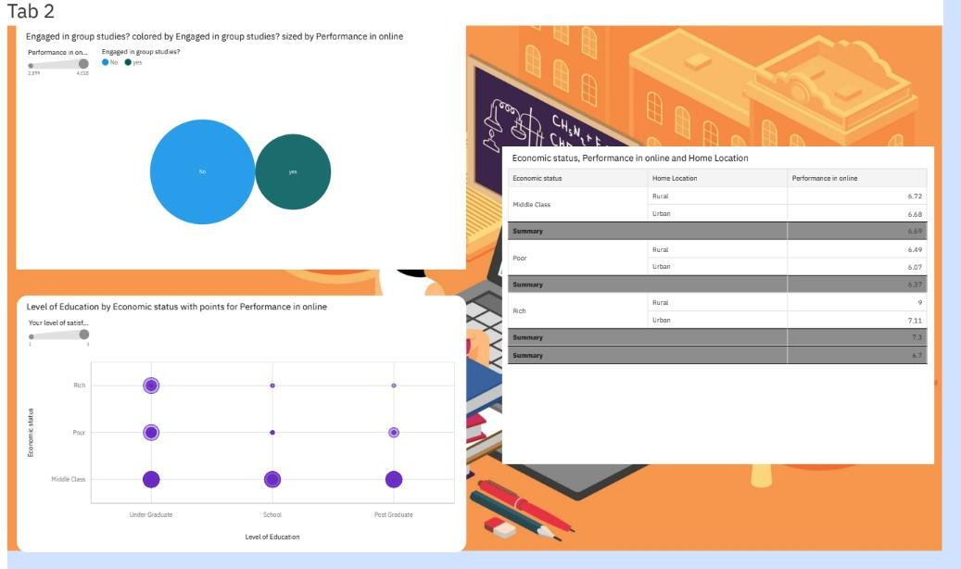

*Figure 2: Visualization 2*

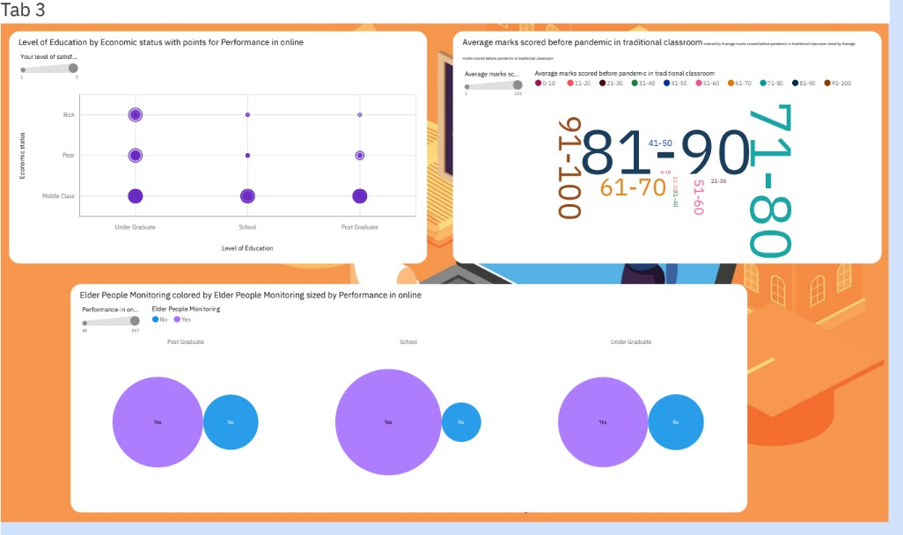

*Figure 3: Visualization 3*



*Figure 4: Visualization 4*

# Story

A story depends on the complexity of the analysis and the specific insights that are trying to be conveyed. It is a visual representation of the data analysis process and it breaks down the analysis into a series of steps or scenes. The number of scenes in a storyboard for a data visualization will analyze the performance and efficiency of online education. The story scenes given in Figure 5 describes the analysis of online education system based on given data.

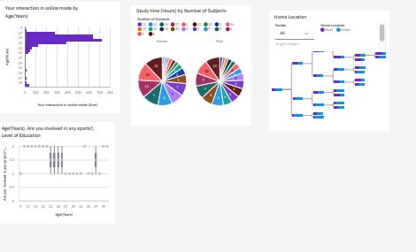

# Report

*Figure 5: Scenes of Story*

In IBM Cognos, a report is a structured presentation of data insights using visual elements like tables, charts, and graphs. It is essential for data analytics as it translates raw data into understandable formats, enabling effective data-driven decision-making. Reports in IBM Cognos facilitate data exploration, visualization, and communication of key insights, forming a cornerstone of robust data analysis processes. Figure 6 and Figure 7 depicts the report generated for the analysis of the virtual classroom in online education system.

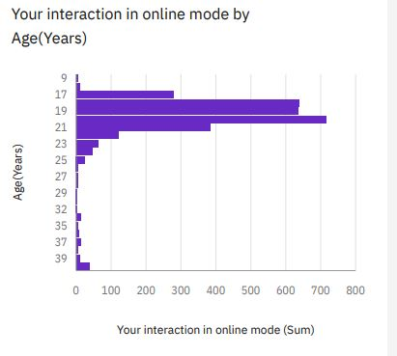

*Figure 6: Report Part-1*

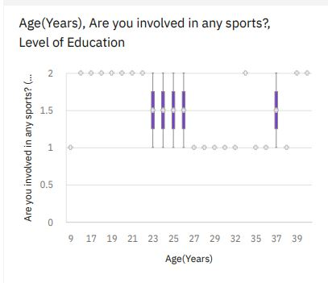

*Figure 7: Report Part-2*

# References

1. George, S. (2005). Connectivism: A learning theory for the digital age. International Journal of Instructional technology and distance learning, 2(1), 3-10.
2. Allen, I. E., & Seaman, J. (2017). Digital Compass Learning: Distance Education Enrollment Report 2017. Babson survey research group.
3. Duke, B., Harper, G., & Johnston, M. (2016). Connectivism as a digital age learning theory. The International HETL Review, 2016(Special Issue), 4-13.
4. Dziuban, C., Graham, C. R., Moskal, P. D., Norberg, A., & Sicilia, N. (2018). Blended learning: the new normal and emerging technologies. International journal of educational technology in Higher education, 15, 1-16.
5. Hwang, G. J., Lai, C. L., & Wang, S. Y. (2015). Seamless flipped learning: a mobile technology-enhanced flipped classroom with effective learning strategies. Journal of computers in education, 2, 449-473.
6. Tsay, C. H. H., Kofinas, A., & Luo, J. (2018). Enhancing student learning experience with technology-mediated gamification: An empirical study. Computers & Education, 121, 1- 17.
7. Kashive, N., & Mohite, S. (2022). Use of gamification to enhance e-learning experience. Interactive Technology and Smart Education.
8. Borba, M. C., Chiari, A. S. D. S., & de Almeida, H. R. F. L. (2018). Interactions in virtual learning environments: new roles for digital technology. Educational Studies in Mathematics, 98, 269-286.
9. Bates, A. W. (2015). Teaching in a digital age: Guidelines for designing teaching and learning. BCcampus.
10. Yavuzalp, N., & Bahcivan, E. (2021). A structural equation modeling analysis of relationships among university students’ readiness for e-learning, self-regulation skills, satisfaction, and academic achievement. Research and Practice in Technology Enhanced Learning, 16(1), 15.
11. Becker, S. A., Cummins, M., Davis, A., Freeman, A., Hall, C. G., & Ananthanarayanan,

V. (2017). NMC horizon report: 2017 higher education edition (pp. 1-60). The New Media Consortium.

1. Nambiar, D. (2020). The impact of online learning during COVID-19: students’ and teachers’ perspective. The International Journal of Indian Psychology, 8(2), 783-793.